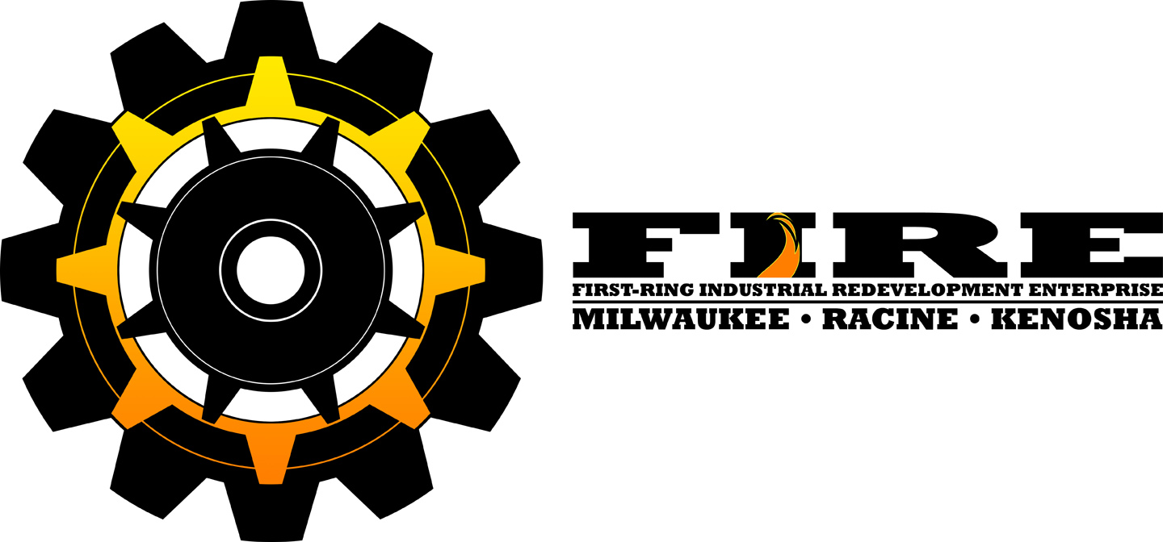

FOR IMMEDIATE RELEASE FOR INFORMATIO CONTACT:

November 7, 2022, John F. Stibal President
First-ring Industrial Redevelopment Enterprises, Inc. (FIRE)

(414) 239-4837
Email: jfstibal@gmail.com

U.S. Treasury awards First-ring Industrial Redevelopment Enterprise, Inc. (FIRE) $35 million in New Markets Tax Credits
West Allis, Wisconsin (November 7, 2022) — First-ring Industrial Redevelopment Enterprise, Inc. (FIRE), announced today that it was chosen by the CDFI Fund of U.S. Department of Treasury to receive a $35 million-dollar New Markets Tax Credit (NMTC) allocation. The allocation will allow FIRE to provide subordinated gap financing to business and non-profits in this time of increasing interest rates and the challenging impacts of rising construction costs. FIRE was selected through an annual competitive process by the United States Treasury’s Community Development Financial Institutions (CDFI)Funds.
“FIRE is ready to ignite real estate and business investments throughout its service area of southeastern Wisconsin through creative financing” stated John Stibal, President of FIRE. “These funds are truly an economic tool that can bridge that gap of a deal and bring the benefit of investment to neighborhoods in need of jobs and growth.”
FIRE was one of only 107 organizations that were selected through a nationwide competitive application and rigorous review process completing against major banks, state finance agencies, to national development private and public entities to receive a tax credit allocation under the 2021 round of the NMTC program. FIRE is now the only annual competitive applicant to have been selected 9 times in a row.
FIRE participates in the NMTC program to support a mission to foster redevelopment on brownfield sites, incentivizes investment that creates and attracts needed family supporting jobs to older neighborhoods. Since 2007, FIRE has received nearly $400 million of tax credits to invest into older distressed neighborhoods.
“Tax credits are often the fuel that can bring to projects to life, but most importantly, generating substantial long-term, benefits to some of our most neglected neighborhoods,” said John Stibal, president of First-ring Industrial Redevelopment Enterprise, Inc. (FIRE). FIRE can provide subordinated financing and potentially fill about 20% of a project’s costs. With rising interest rates and high construction costs the funding provided by the tax credits are often the critical margin that make projects feasible. FIRE initially provides a very low interest only loan for seven years. At the end of the seven-year period FIRE generally forgives at least 75% of the principal.
“We are pleased that US Treasury CDFI Fund recognizes the contributing efforts of FIRE and the hard work of our investments that have been diverse and impactful serving multiple industries in the older neighborhoods throughout Racine, Kenosha, and Milwaukee Counties” said FIRE Board Chair Mickey Czaplewski.
The NMTC Program is a powerful federal economic development tool designed to promote development into America’s underserved and distressed communities. NMTCs generate private equity when leveraged with other sources of capital to create flexible financing structures for projects in these areas. Federal data show that for every dollar of allocation provided under the NMTC program, an additional $8 of private investment is leveraged for the economic development of these communities.
The NMTC program, established by Congress in December 2000, permits individual and corporate taxpayers to receive a credit against federal income taxes for making qualified equity investments in investment vehicles known as Community Development Entities (CDEs). The credit provided to the investor totals 39 percent of the cost of the investment and the tax credit is claimed over a seven-year period.
FIRE has provided low interest only subordinated loans to projects such as Super Steel, JF Ahern, Palermos Pizza, Festival Foods, Granite Behavioral Health Facility, Cherry Water office complex, Beyond Vision, Discovery World to Tramont Manufacturing.

Headquartered in West Allis, WI, First-ring Industrial Redevelopment Enterprise, Inc. (FIRE) is sponsored by the City of West Allis and formed in 2007 to attract tax credit and other funding incentives for projects that can demonstrate significant and measurable community impact. The company provides below-market rates and terms for equity-equivalent, senior, and subordinate loans products in industrial, healthcare, commercial, mixed-use, and non-profit projects. Projects must be located in older distressed neighborhoods within its four-county service region. To determine if a project meets the locational requirements please check FIRE’s website.
#########
For additional Information please call:

John Stibal
President
First-Ring Industrial Redevelopment Enterprise, Inc.(FIRE)
11934 W. West Hayes Ave. | West Allis, WI 53227
Cell: 414-239-4837
jfstibal@gmail.com
www.fire-nmtc.com | Follow Us on LinkedIn!
This institution is an equal opportunity provider.

